**LAB # *01***

1. Draw a flowchart to add two numbers entered by user with the help of MS Visio tool.

start

Enter the

value of a

and b

sum = a

+

b

print sum

End

1. Draw a flowchart to show basic business process like the proposal development process. Firstly, team members suggest a project then participants decide that if it’s a good idea or not, if team rejects the idea then create further important information and if agrees then create further important information.

START

GAME

APPLICATION

PROPOSAL

REJECT /

APPROVES

INITIAL

PROGRAMMING

OF THE APP



TESTING

CHECKING

FOR ERRORS

AND BUGS



APP READY TO

DELIVERED

END

**APPROVES**

**REJECTS**

3.Draw a flowchart for Registration Form (or signup page). Mention all necessary fields to complete your registration

**YES**

START

Submit the

registration form

form

complete?

Verifying details

**NO**

END



Registration

form

submitted

successfully

Accept

submission?

notifying

student on

rejection

**NO**

Registration

Succefful

**YES**

**LAB # *02***

***Advanced Concepts Using MS Visio***

### *Exercise*

*Develop a computer lab scenario using advanced options in MS Visio.*

* **Advanced options:**

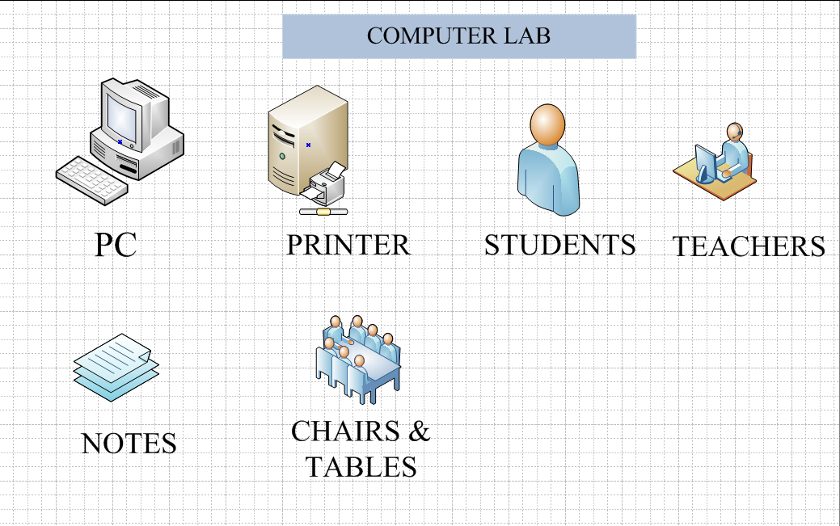

* **Scenario :**

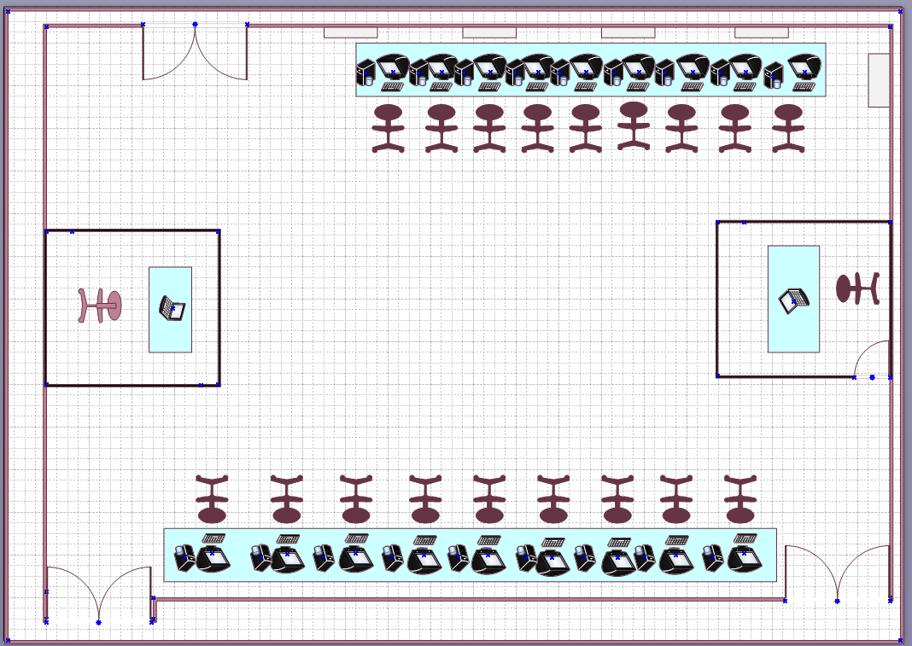

* **Flowchart:**

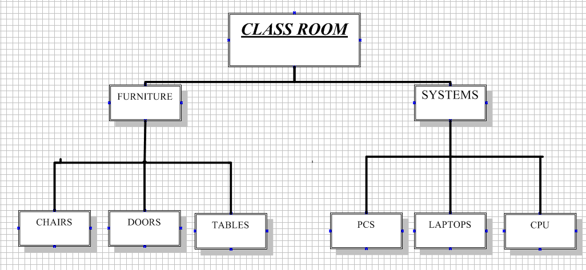

**LAB # *03***

## *Creating Gantt Chart and PERT Chart using MS Project*

### *Exercise*

*Create Gantt Chart and Network Diagram in Microsoft Project with above mention projects.*

### Exercise # 01

1. *Social website like (Facebook, Twitteretc.)*

***GANTT CHART:***

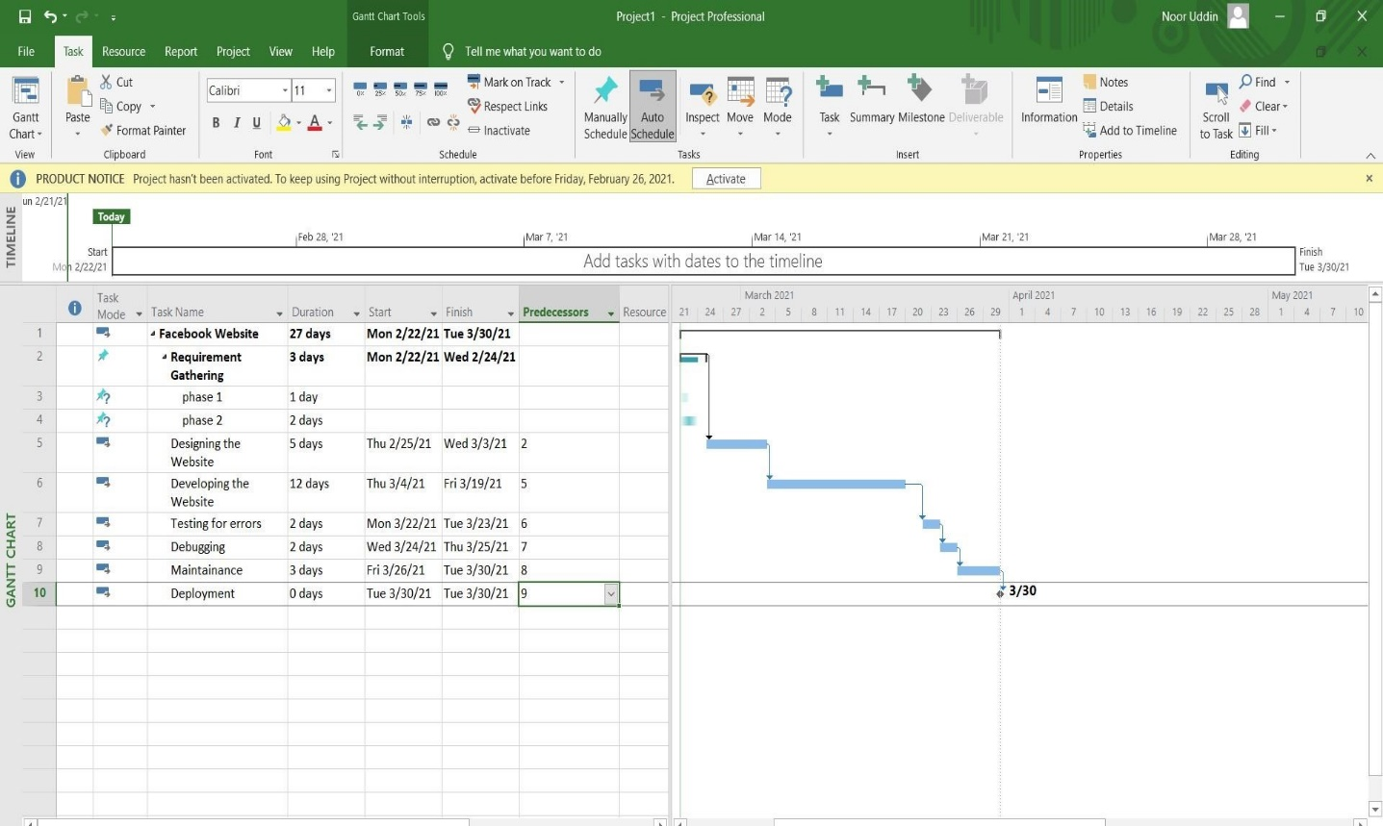

***NETWORK DIAGRAM:***

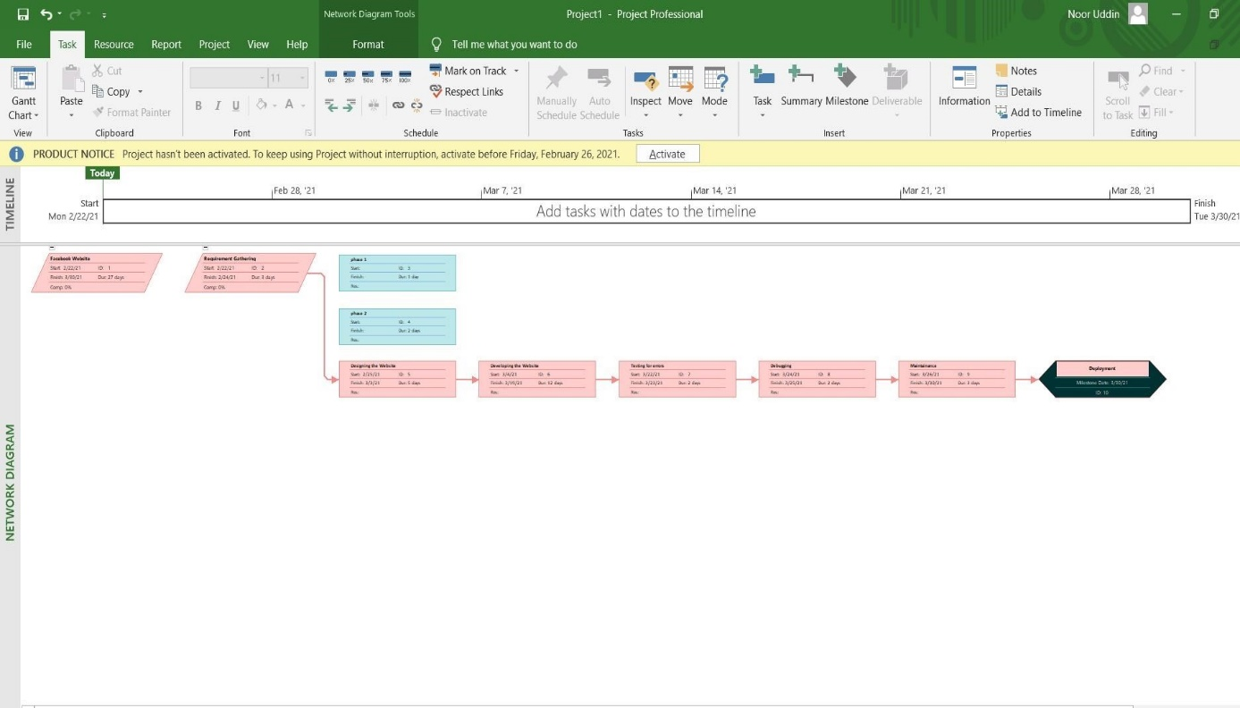

### Exercise # 02

1. Hospital Management System

***GANTT CHART:***

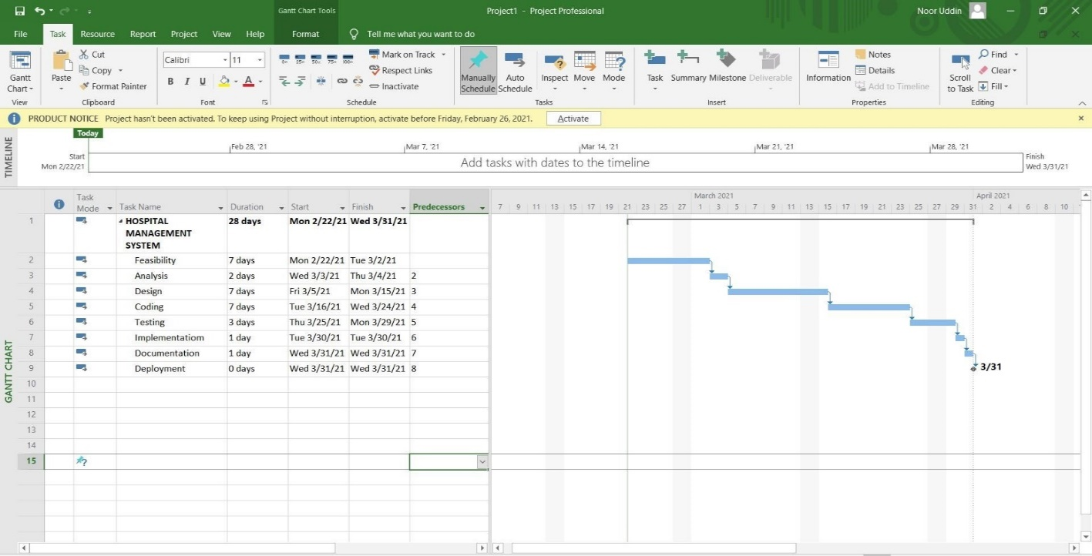

***NETWORK DIAGRAM:***

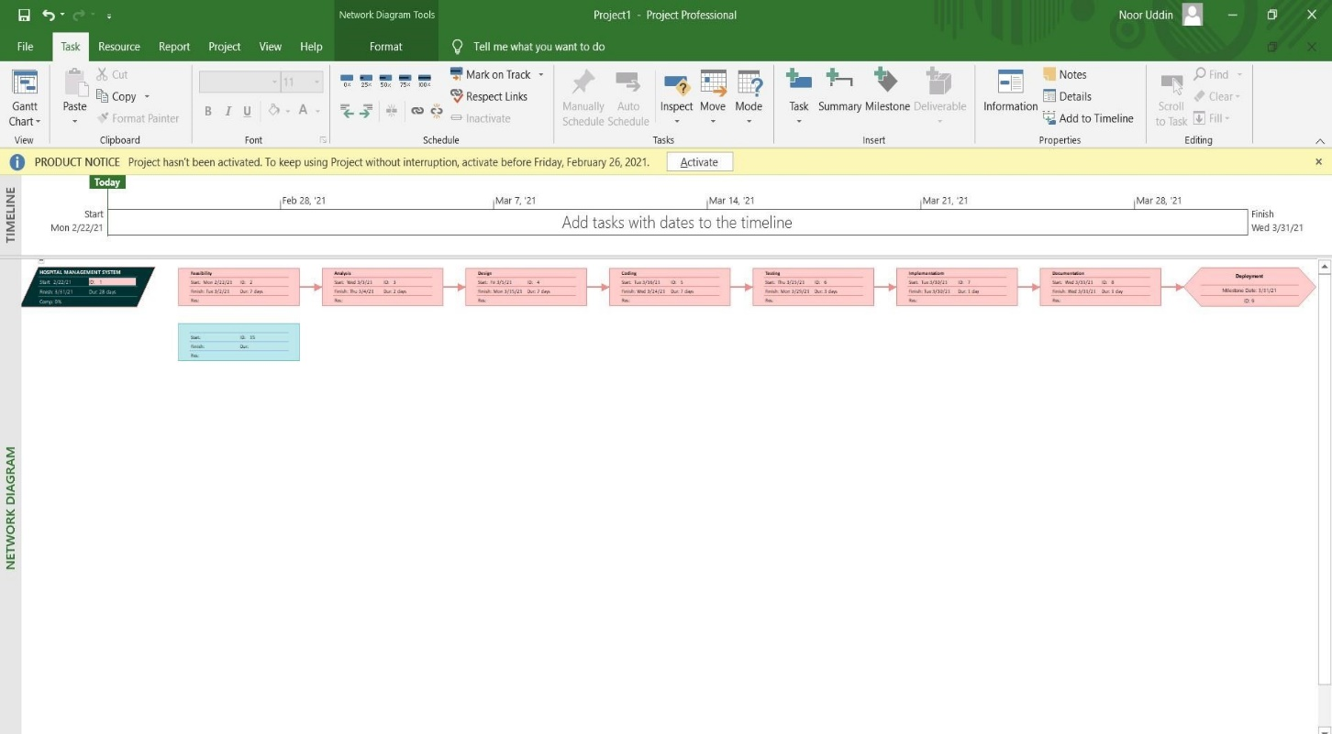

### Exercise # 03

1. Faculty Management System

***GANTT CHART:***

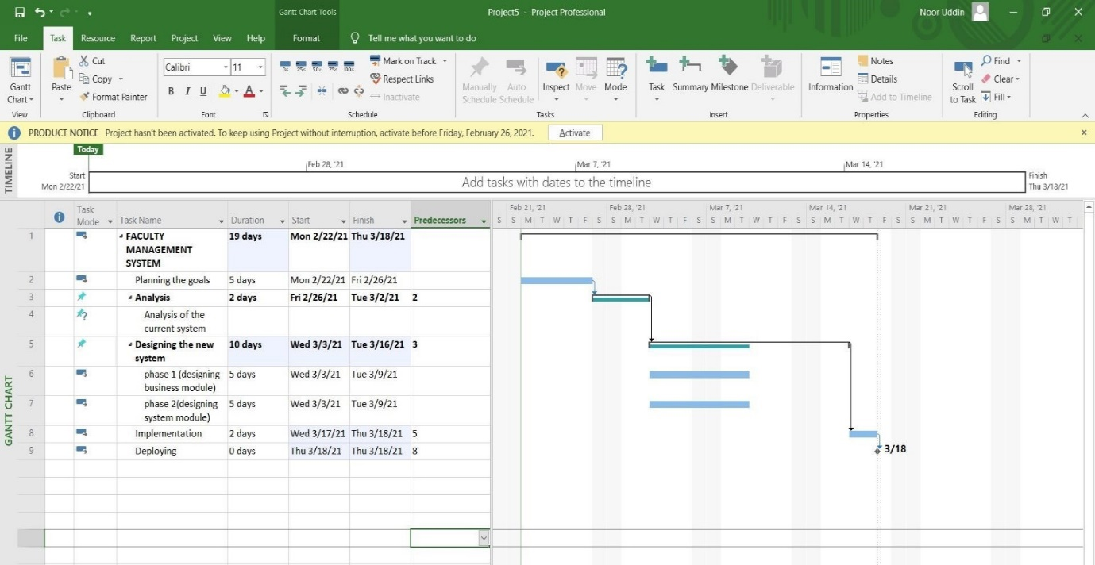

***NETWORK DIAGRAM:***

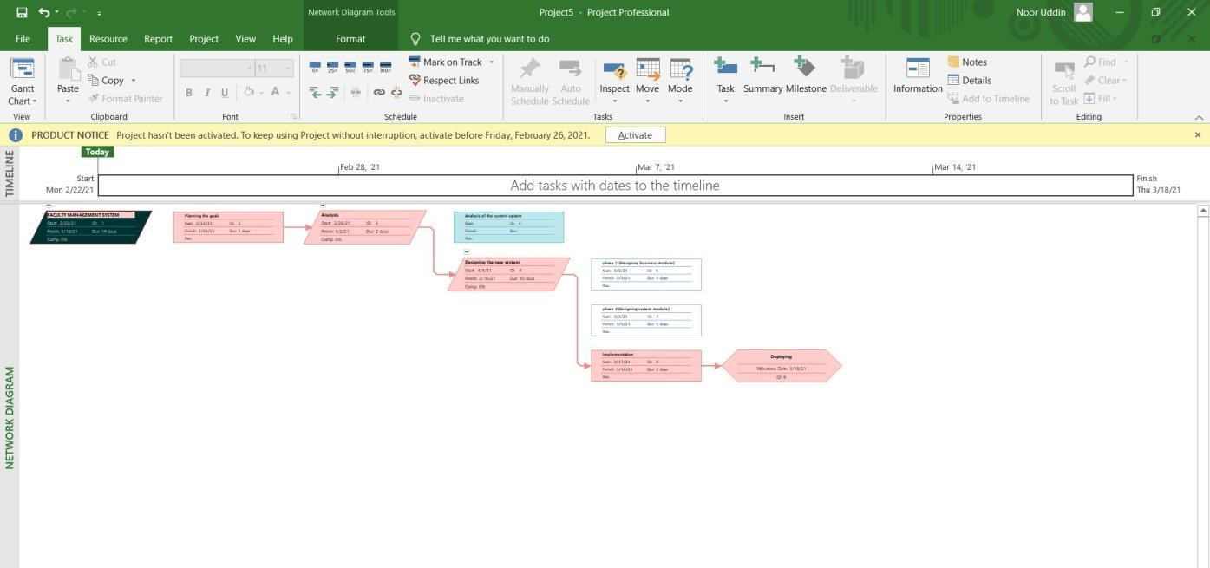

**LAB # *04***

***Introduction To Rational Rose***

### *Exercise*

* + *Create Use Case Diagram which relate to a Web site on which customers can order meals from restaurants.*

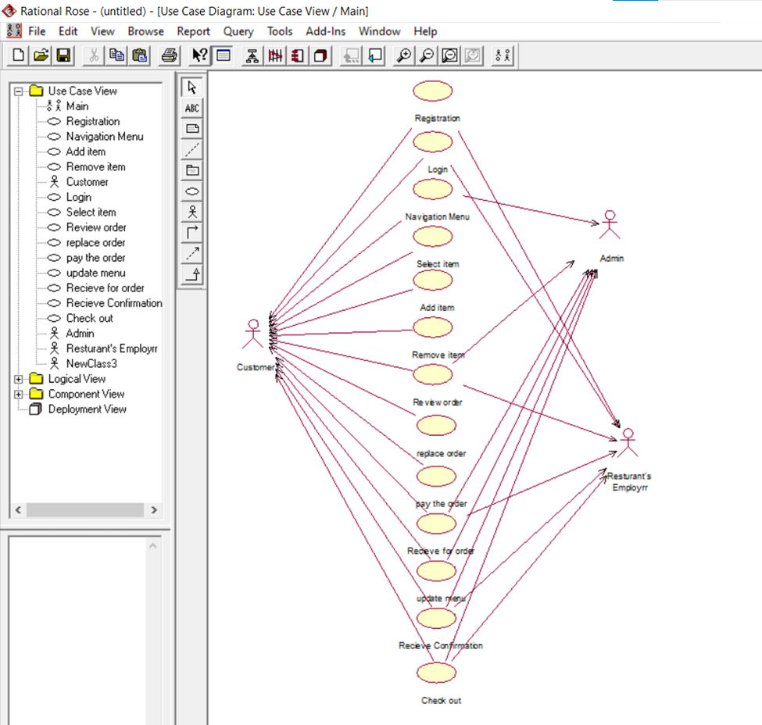

***TASK#4.2***

* + *Create Website management or administration UML use case diagram, website administrator actor could manage user groups, users, user sessions, and logs. Help Desk staff uses a subset of functions available to the Website Administrator.*

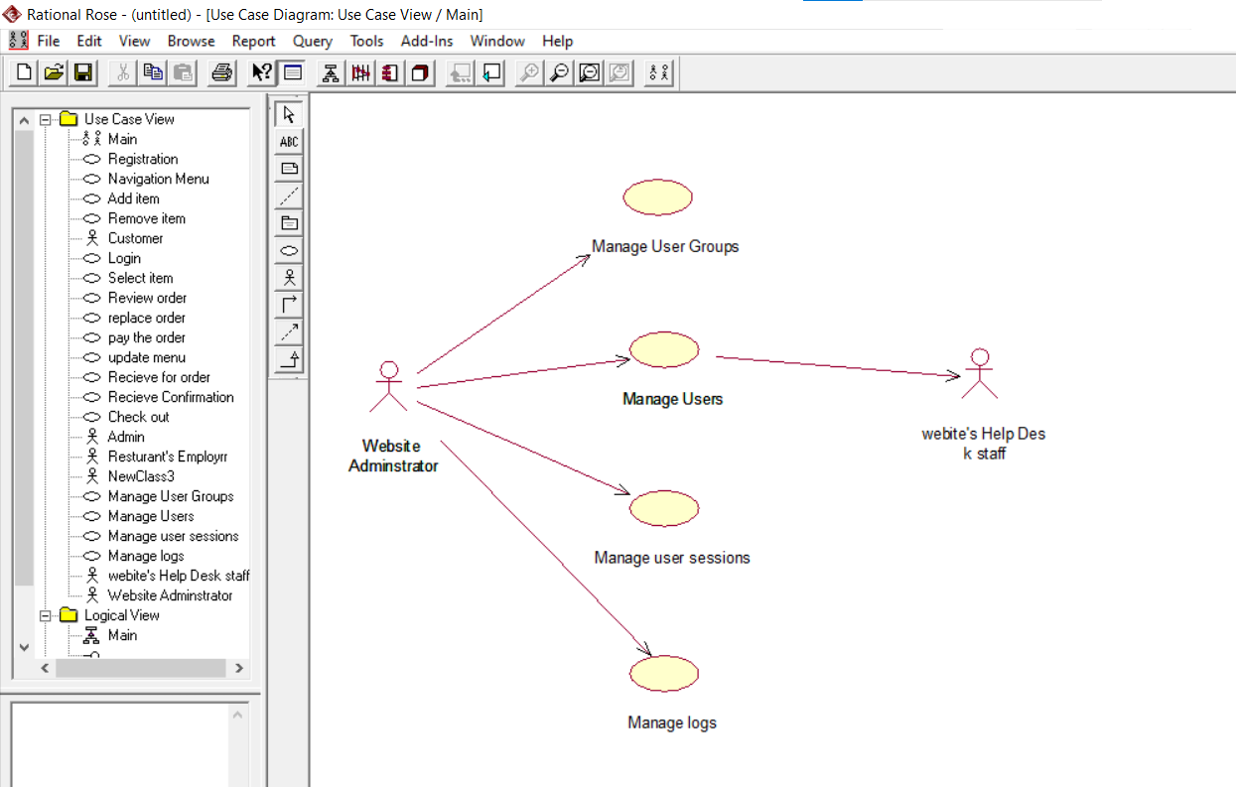

***TASK# 4.3***

* + *Create use case scenario between patient and doctor relationship.*

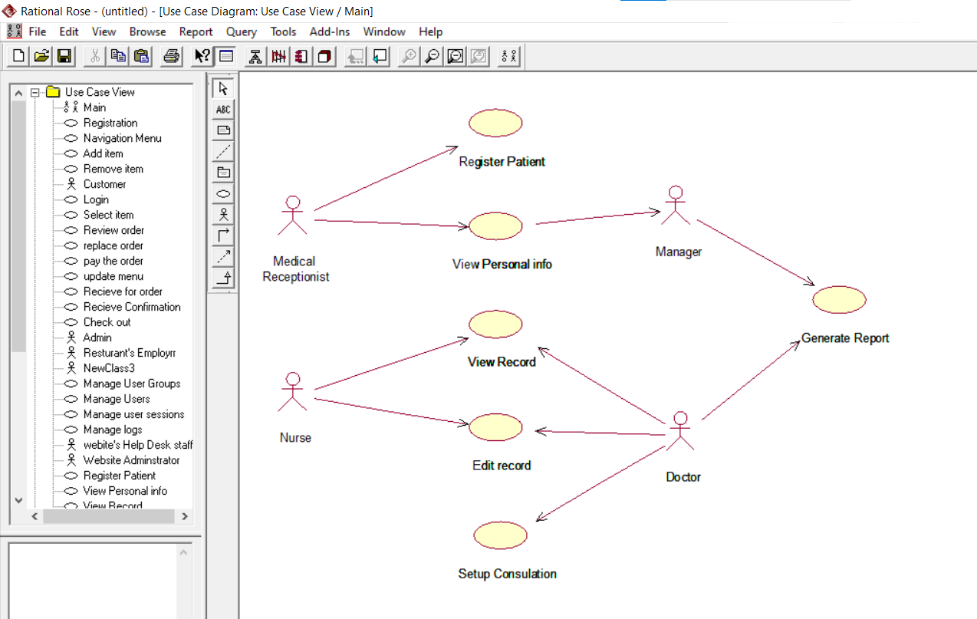

***TASK# 4.4***

* + *Create use case diagram of Login scenario. In this scenario, authorized admin and user duties*.

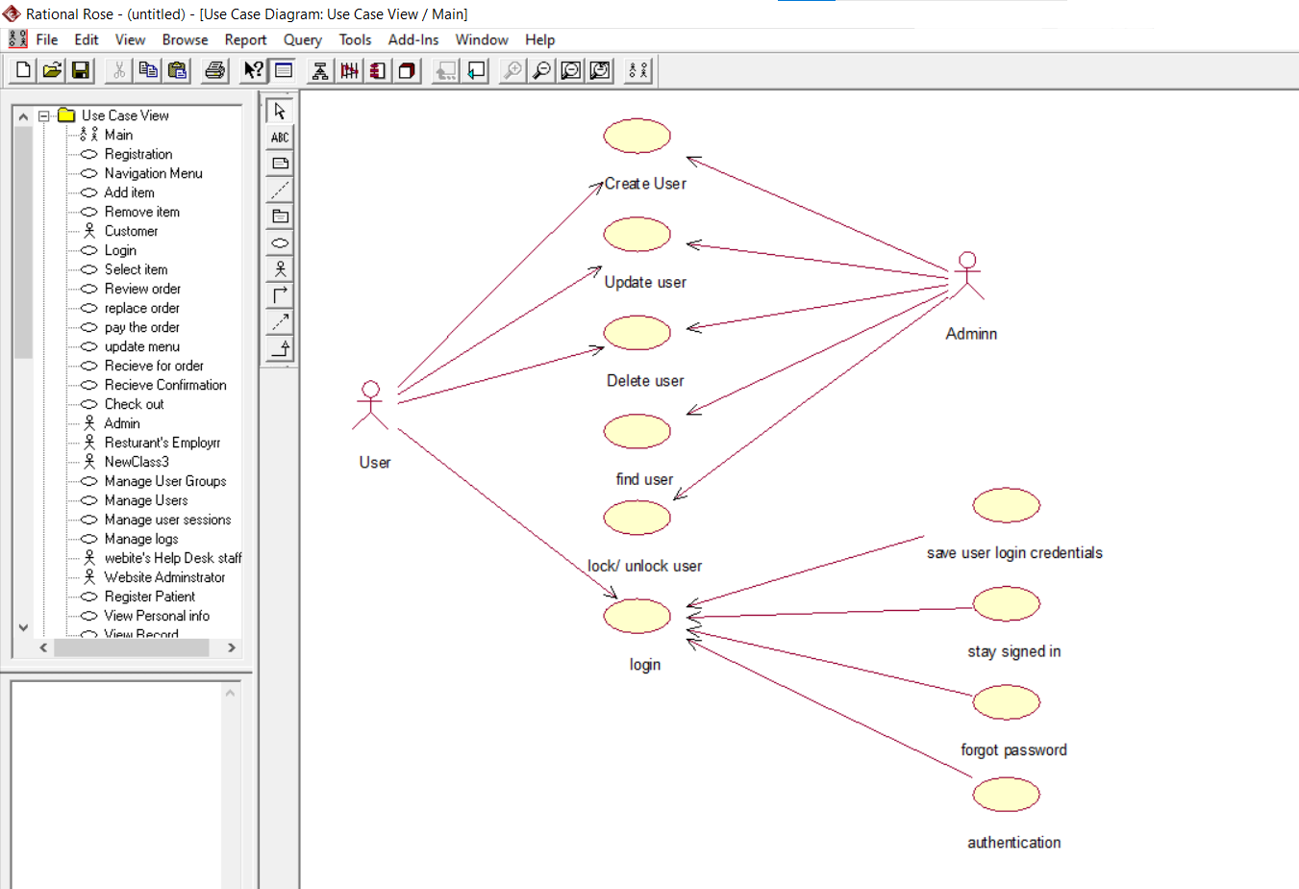

**LAB # *05***

***Illustrate Use Case Diagram Using “Rational Rose”***

### *Exercise 5.1:*

*Draw a use case diagram of the stated scenario: A user has all the rights of login to a catalog management website browse the catalog and view products. Similarly, the administrator of that website has all the rights that a user has but in addition to that administrator has other rights too that include Logout, create product, edit product and to delete product. Find out the actors and relation of actor or actors to the use cases. Note: Show the relevant association of actors with the use cases.*

*State the Actors and Use Cases of the above stated scenario and describe briefly the dependencies between them*

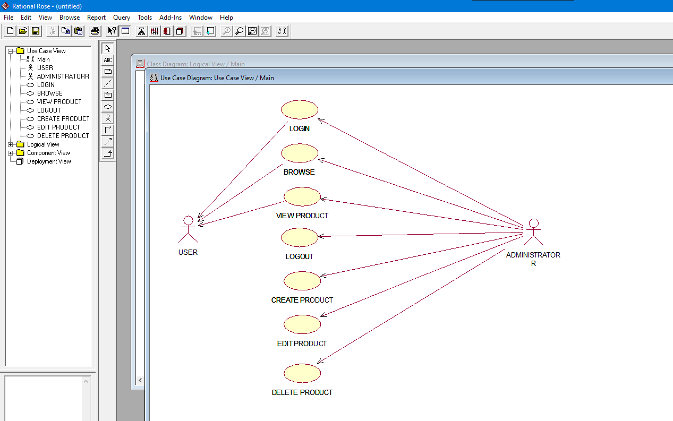

### *Exercise 5.2:*

*At the start of each semester a student can request a prospectus containing a course list. Information about a course is provided, such as the tutor, department and pre-requisites. The new system will allow students to create a schedule, then select four courses. Each student chooses two others in case their first choices become full or are cancelled. No course can have more than 10 students. No course can have less than 3 students or it will be cancelled. This will be the same functionality as available to other internal users of the system. When registration is complete, the registration system sends a message to the billing system to send out a bill to the student. Tutors use the system to find which classes they are teaching and who the students are. The registrar will administer the system. For a period at the beginning of the semester the student can change their schedule. Students must be allowed to access the system during this time to add or delete courses. Identify the Actors, Use Cases and Association of the given scenario.*

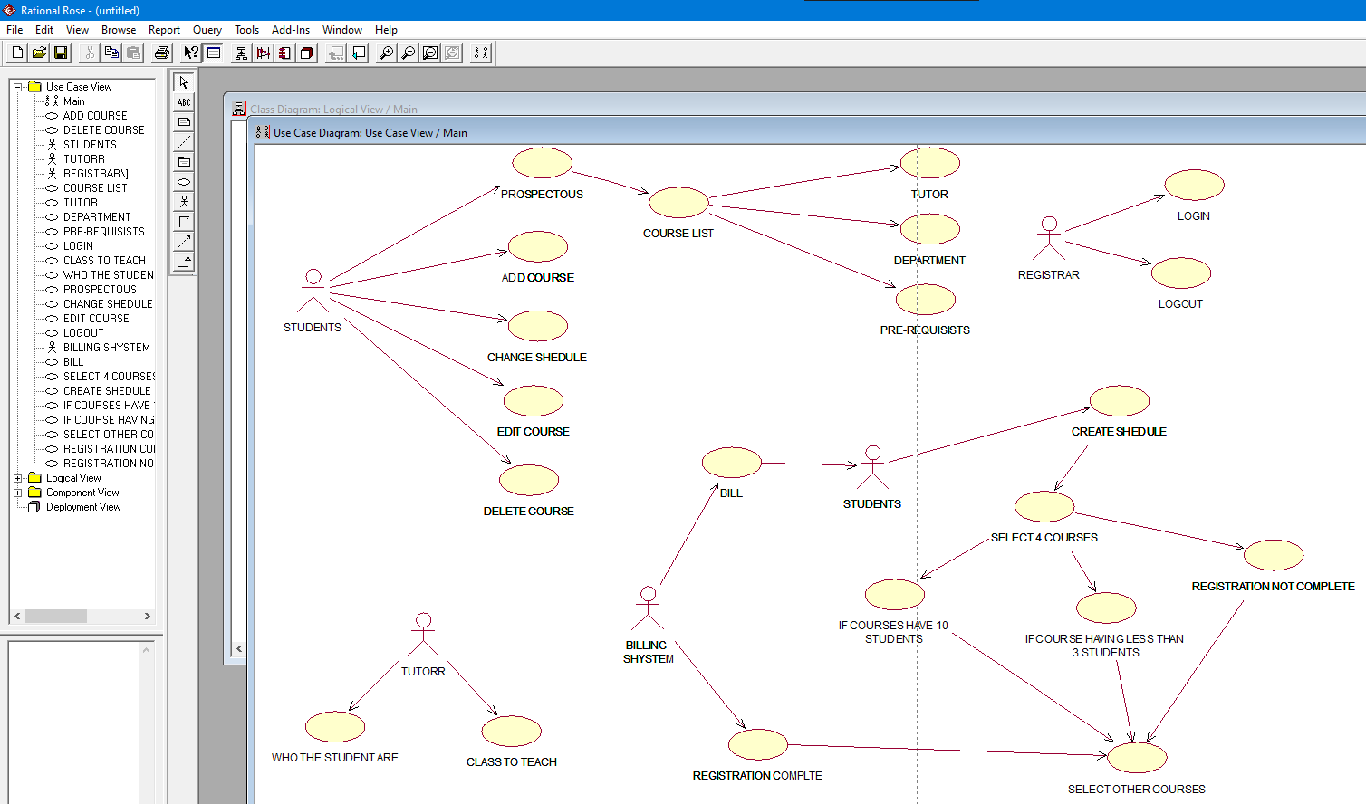

### *Exercise 5.3:*

***For the hospital Management System, a general example is shown below.***

*The Actors and their use cases are identified as: -*

***Task 1****: Receptionist--Interact with Visitors; Give appointments to Medical Representatives, Revert to Phone Queries, Handles Patient Registration.*

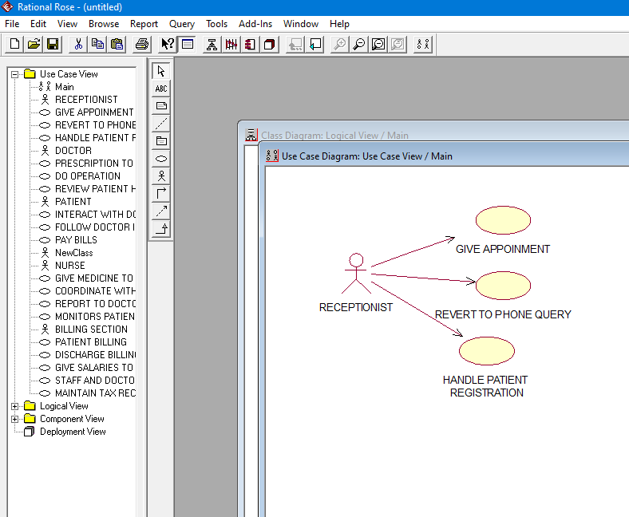

***Task 2****: Doctors--Give prescription to Patient, Do Operation, and Review Patients health.*

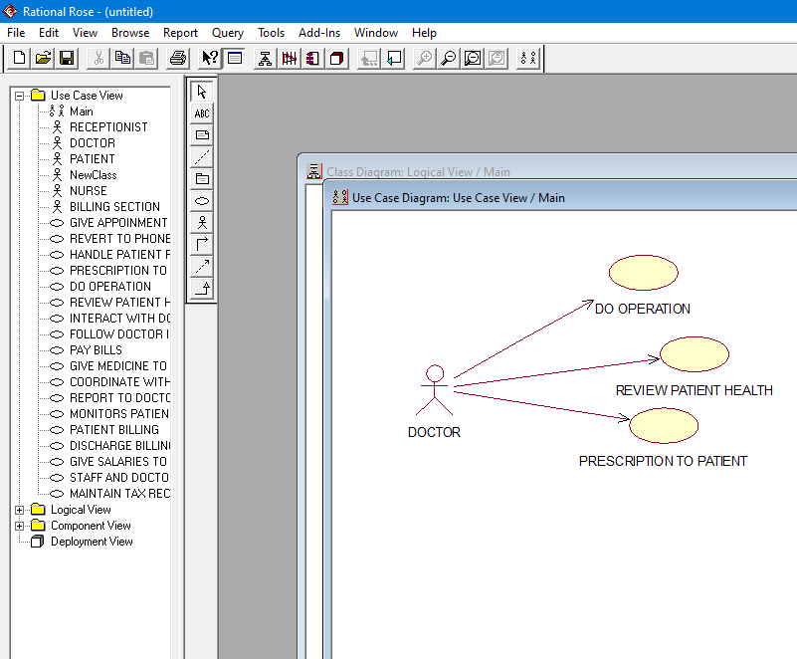

***Task 3:*** *Nurse--Give Medicine to Patient, Coordinate with Doctors in Operation, Report to doctors, Monitors Patients health.*

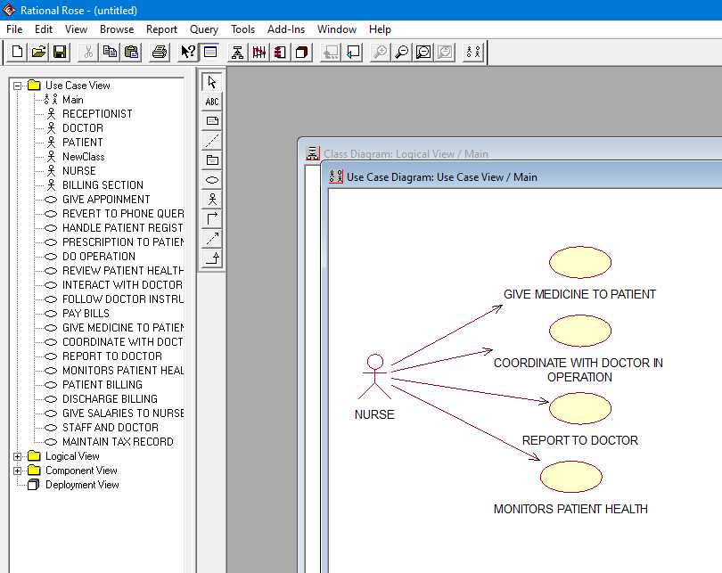

***Task 4:*** *Patient--Interact with Doctor, Follow Doctor Instructions, Pay Bills.*

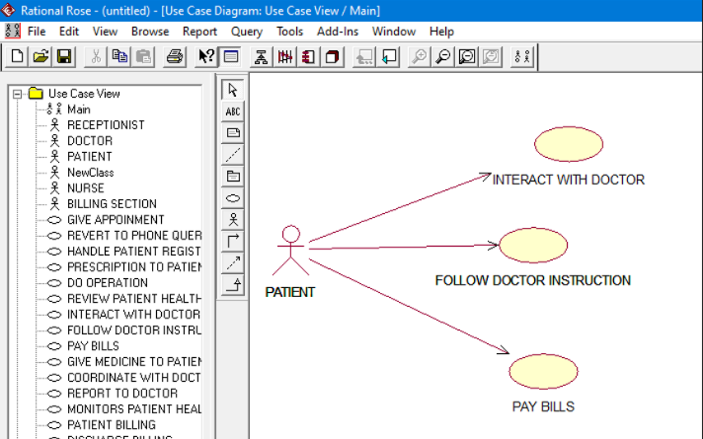

***Task 5:*** *Billing Section--Patient Billing, Discharge Billing, give salaries to Nurse, Staff and Doctors, Maintain Tax Records.*

*Here for the Billing Section we have considered Patient Billing and Discharge billing as separate, as the Patient might not be admitted and is charged for only counseling. Draw the Use Case Diagram for the above scenario.*

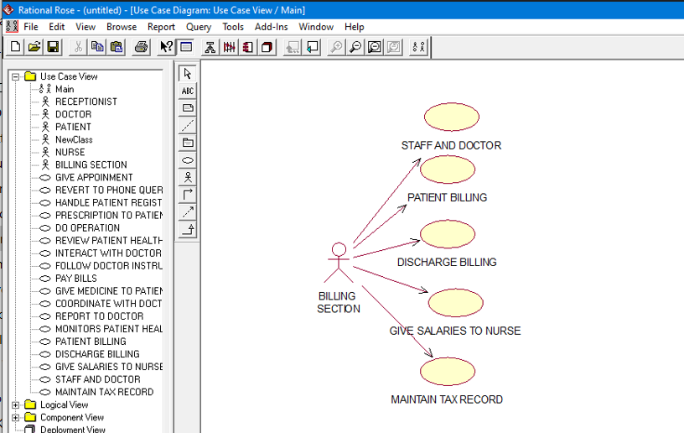

**LAB # *06***

***Working with class Diagram of UML***

### *Exercise 6.1:*

***Develop a Class Diagram using the specifications given below:***

*• Add the PeopleInformation, UniversityArtifacts, and Interfaces packages to the Main class diagram.*

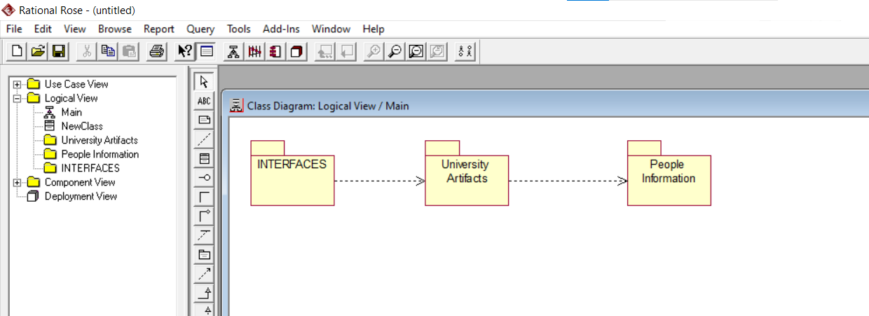

**Create the Main class diagram for each package**

*. • Add the StudentInformation and ProfessorInformation classes to the PeopleInformation package Main class diagram.*

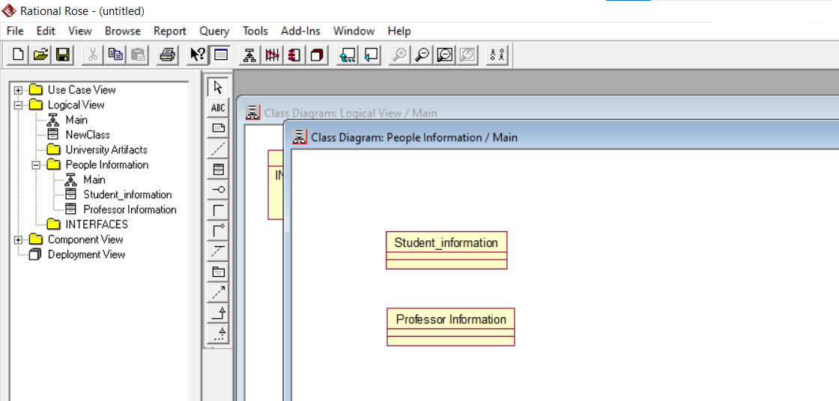

*• Add the Course and CourseOffering classes to the UniversityArtifacts package Main class diagram*

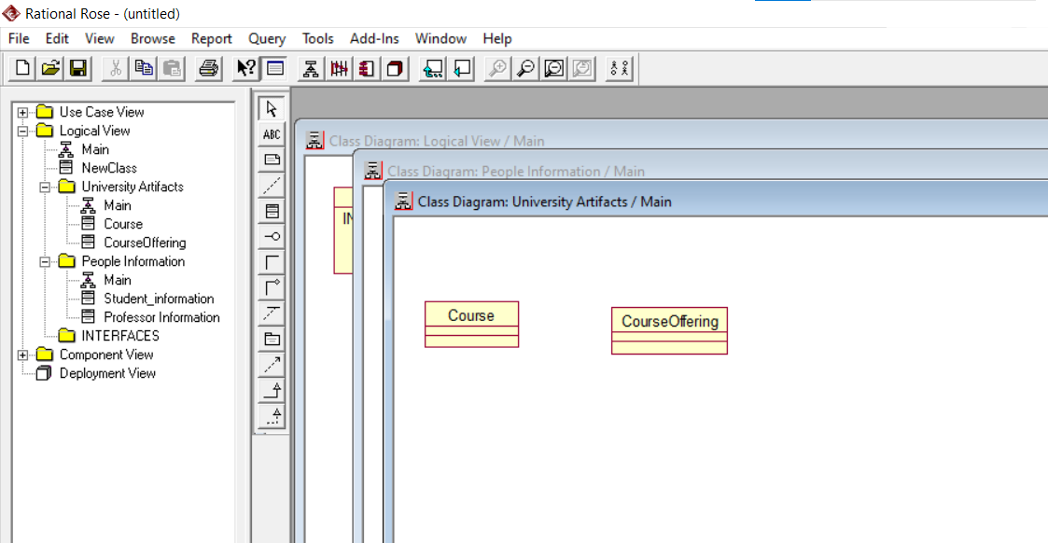

*. • Add the CourseOptionsForm and CourseForm classes to the Interfaces package Main class diagram.*

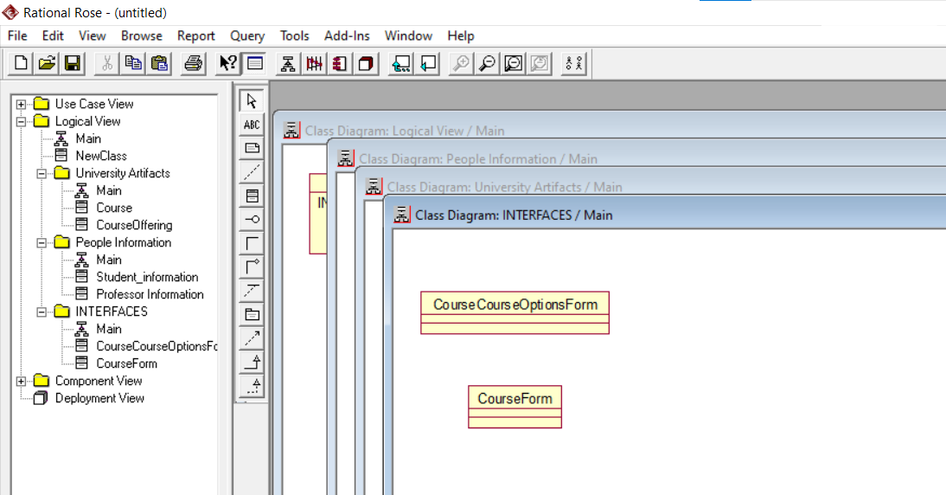

*• Create a new class called Catalog using the toolbar and place it on the UniversityArtifacts package Main class diagram. Don‘t forget to document the new class.Create a new class diagram called Course Information for the UniversityArtifactspackage. Add the Course class to the Course Information class diagram*

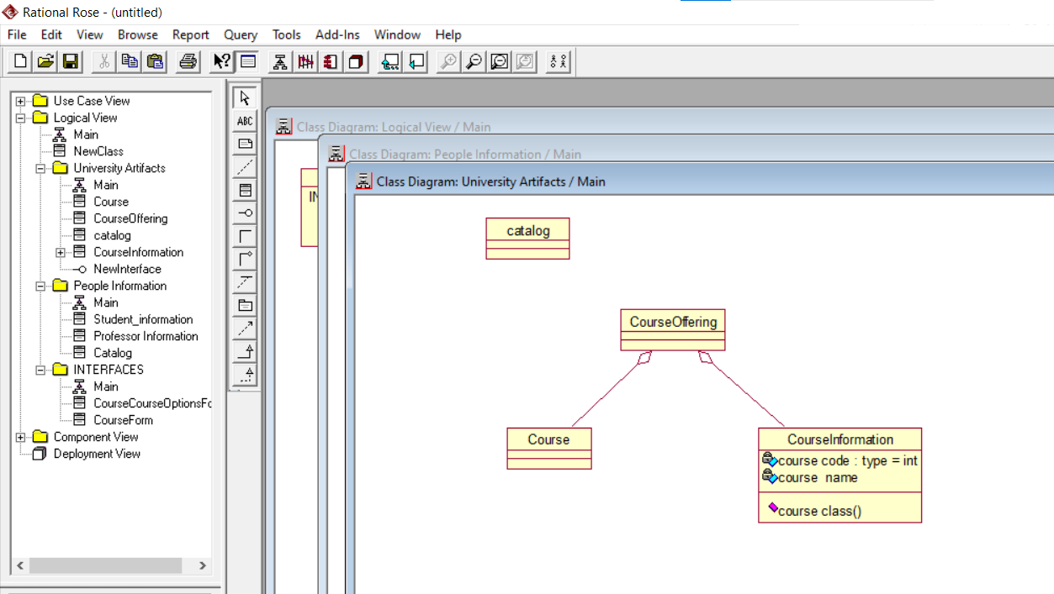

**LAB # *07***

***Illustrate Sequence Diagram Using “Rational Rose”***

### *Exercise 7.1:*

***Model a Sequence Diagram for login operation***.

• *The new customer will enter his/her user id& password and then click on login button on the login.aspx Webpage.*

*• The Session Manager gets the user id and user details from Customer class instance and verifies the user id and password.*

*• If user details are invalid customer will not be allowed to login and an appropriate error message will be displayed, otherwise the customer is logged in.*

*• Add the People Information, University Artifacts, and Interfaces packages to the Main class diagram.*

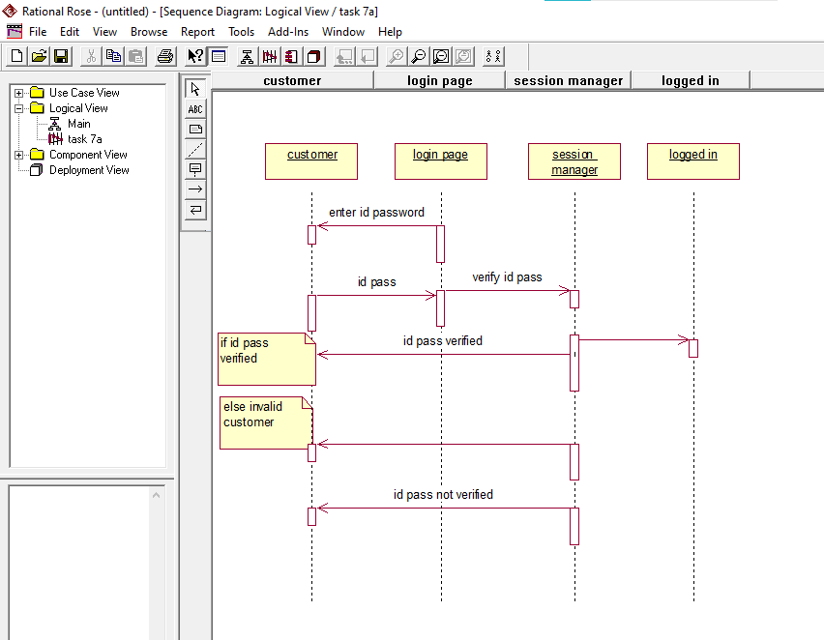

### *Exercise 7.2:*

***Model a Sequence Diagram for the Library Management System***.

*There is a volume of students renting books from the library. To regulate this, it’s essential for students to have online access to the record of available books. This system sequence diagram example is just made for this purpose. Also, the system will also inform the student if they exceeded the allotted time for renting a book and a penalty will apply accordingly*

*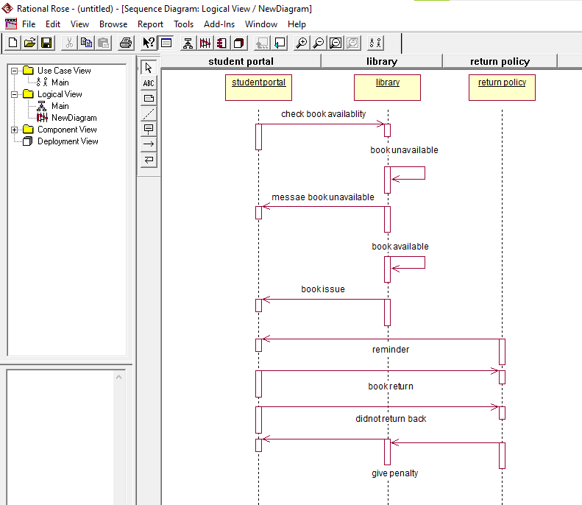.*

**LAB # *09***

***Apply Web Development framework using “Dreamweaver CS5”***

### *Exercise 9.1:*

*2) Explore and implement the other forms of lists (ordered list and definition list).*

*3) Explore and implement the Email link tag from the insert menu. Insert → Emaillink*

***Output:***

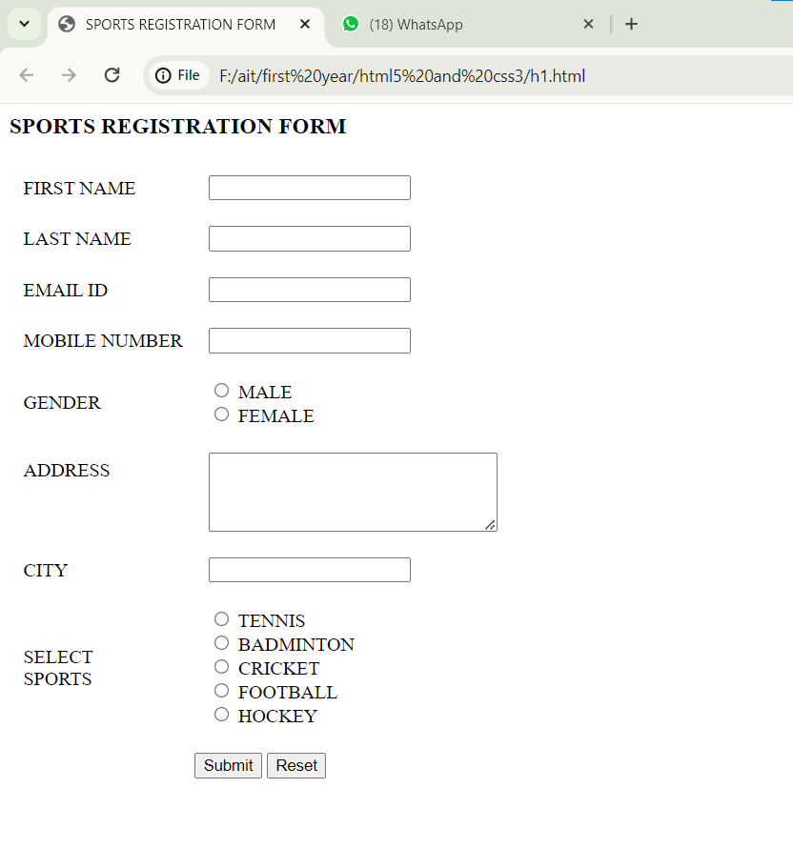

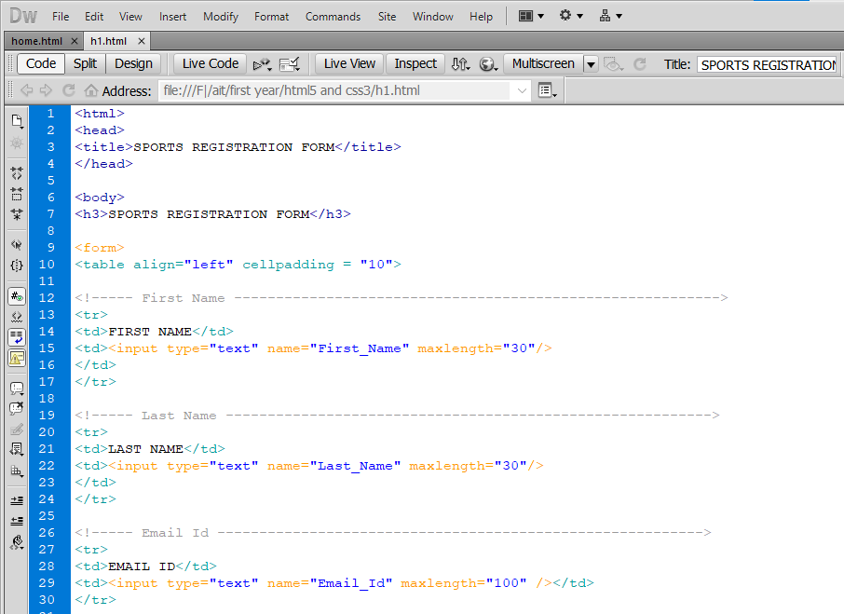

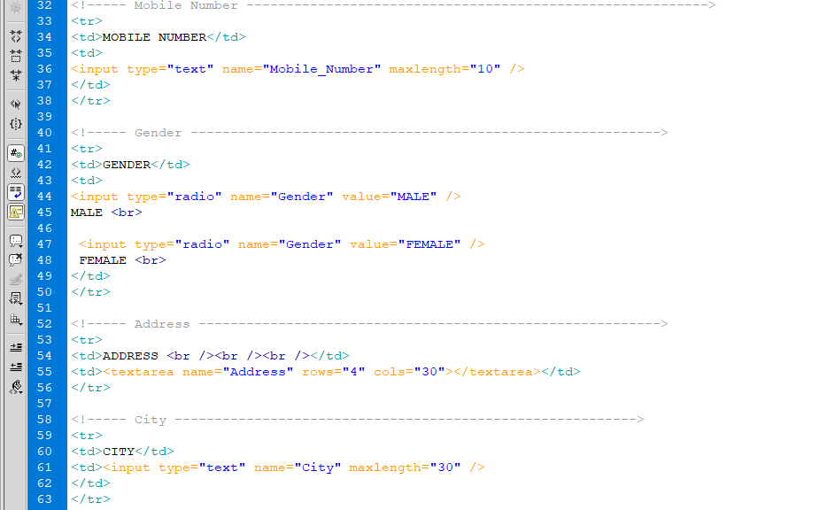

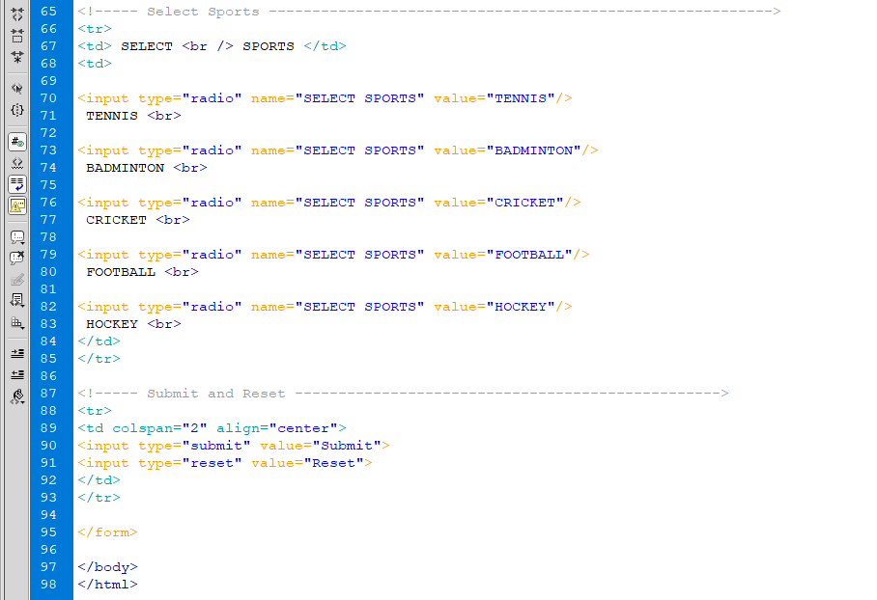

**LAB # *10***

***Apply Web Development Client Side Scripting HTML, Login form, CSS and Java Scripting***

### *Exercise 10.1:*

***Code:***

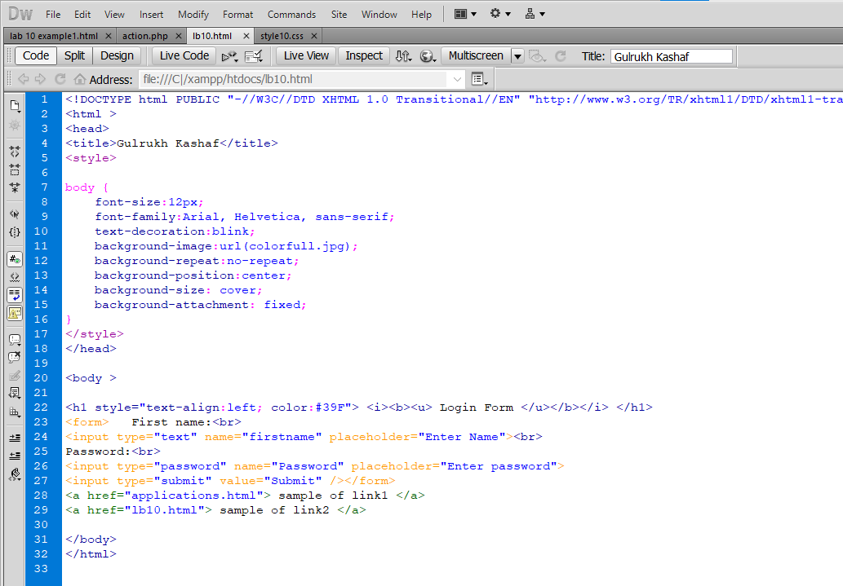

***Output:***

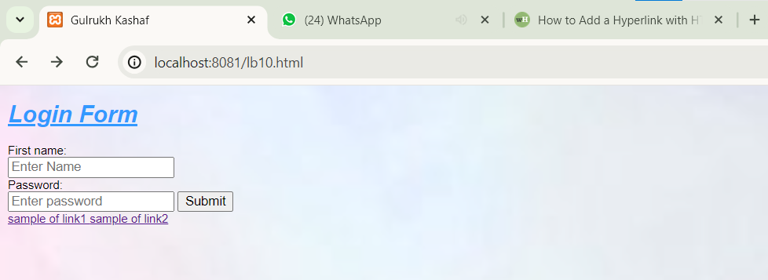

***Lab # 11***

***USE CASE DIAGRAM***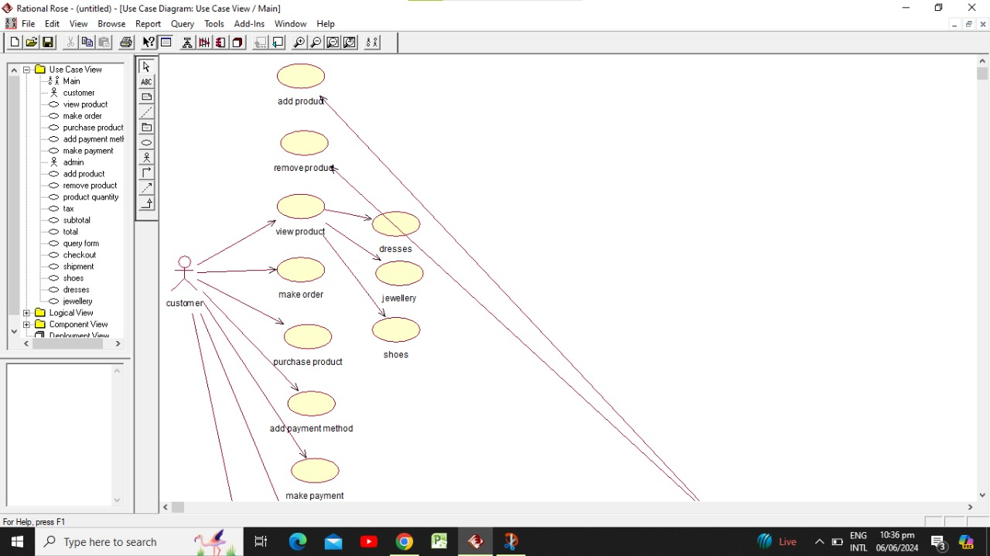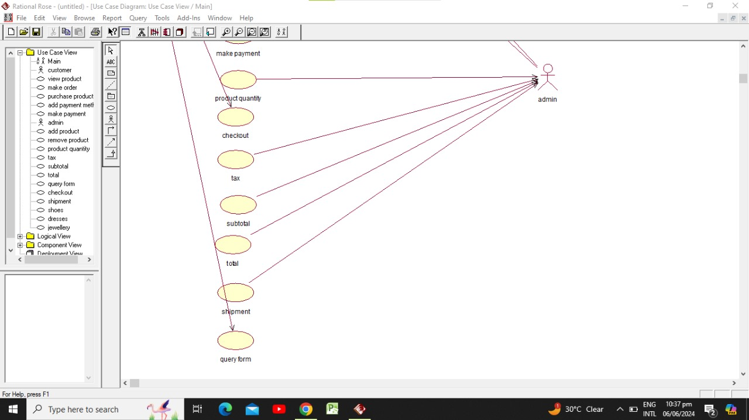

***CLASS DIAGRAM*** 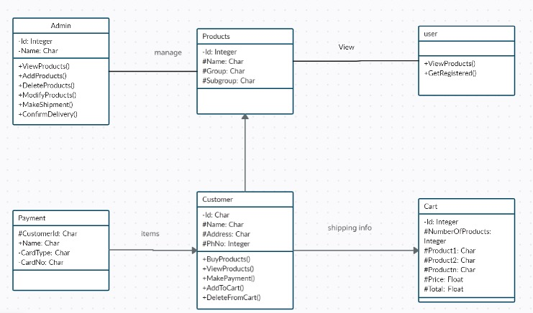**SEQUENCE DIAGRAM**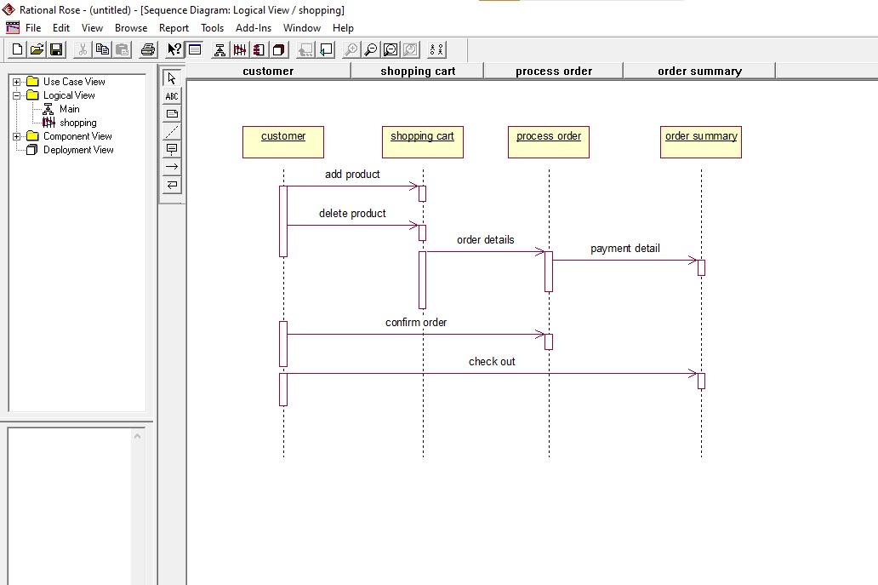

**NETWORK DIAGRAM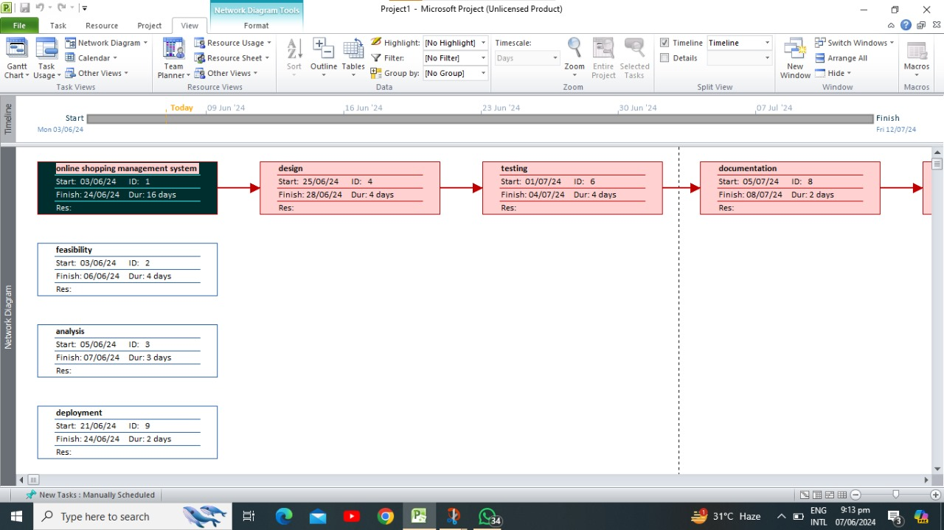GANT CHART**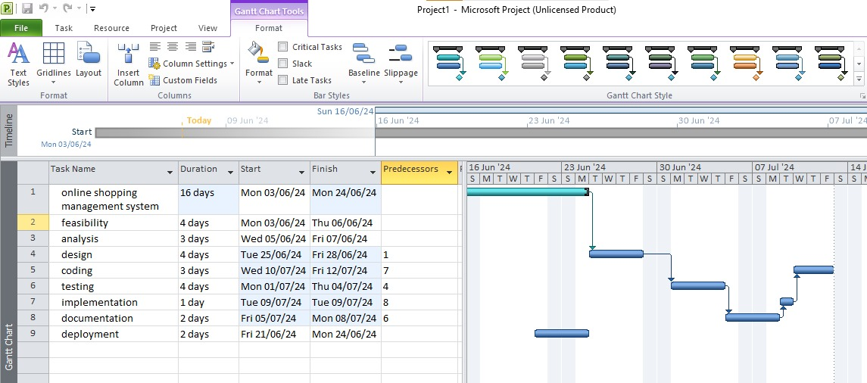

**LAB # *12***

***Implement Server Site Scripting on MYSQL***

*The following illustrates the BikeStores database diagram:*

*The BikeStores sample database has two schemas sales and production, and these schemas have nine tables.*

*Create the given tables with the mentioned fields using XAMPP Server*.

***Create 9 database :***

***Database # 01 “Customer”:***

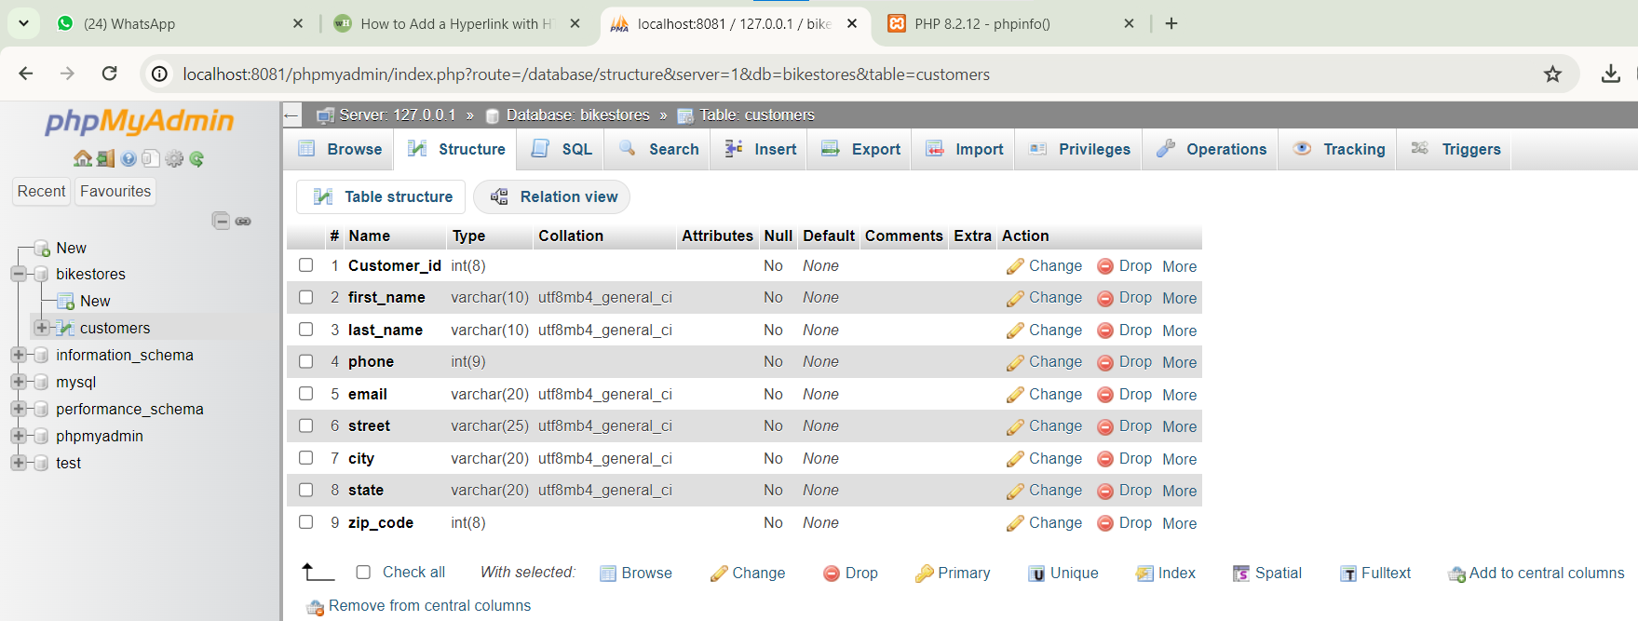

***Database # 02 “Staff”:***

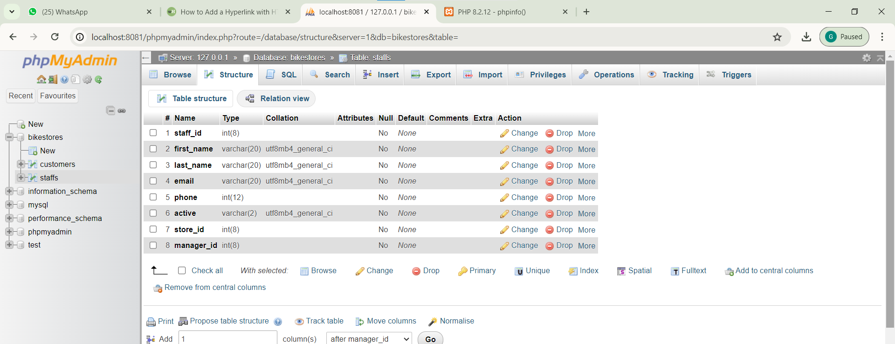

***Database # 03 “orders”:***

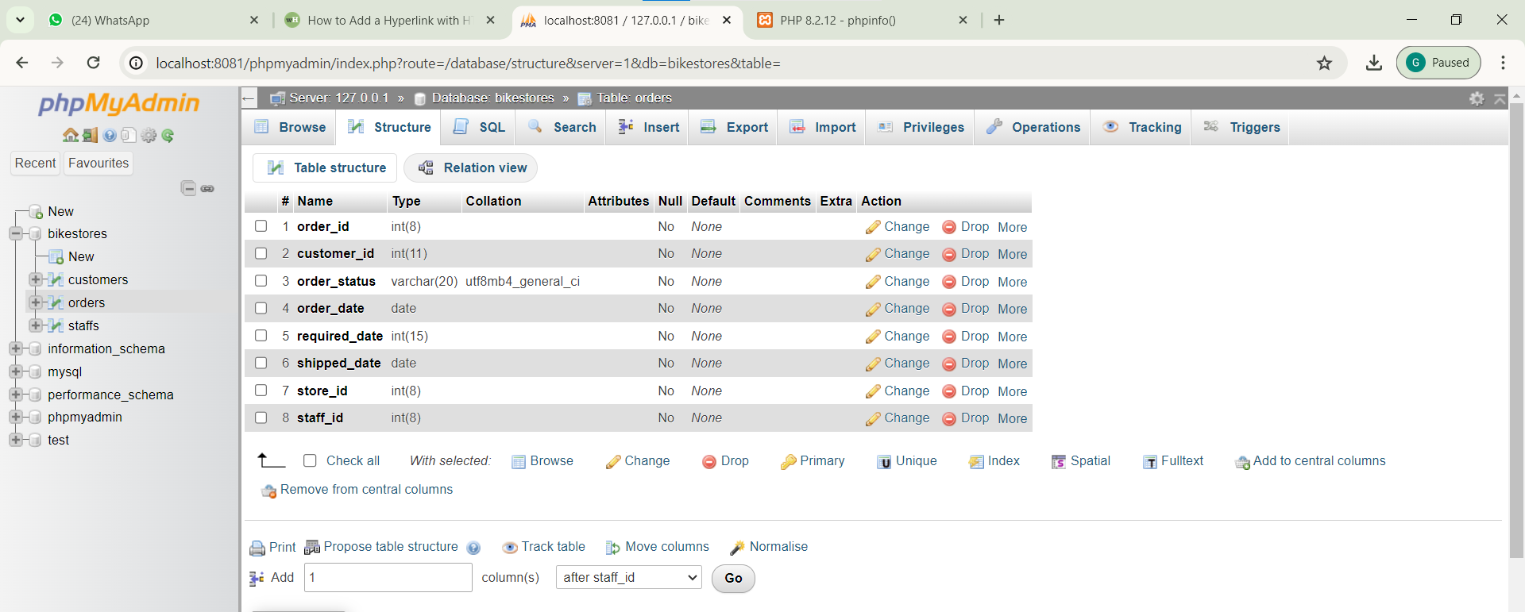

***Database # 04 “Stores”:***

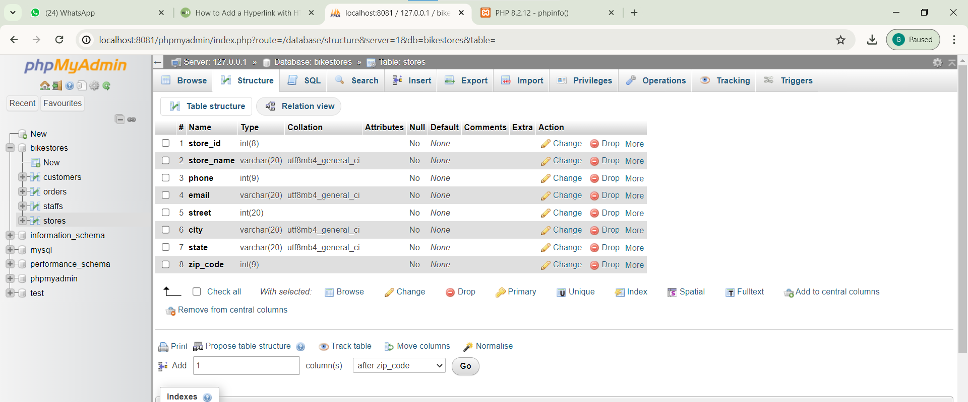

***Database # 05 “Order_items”:***

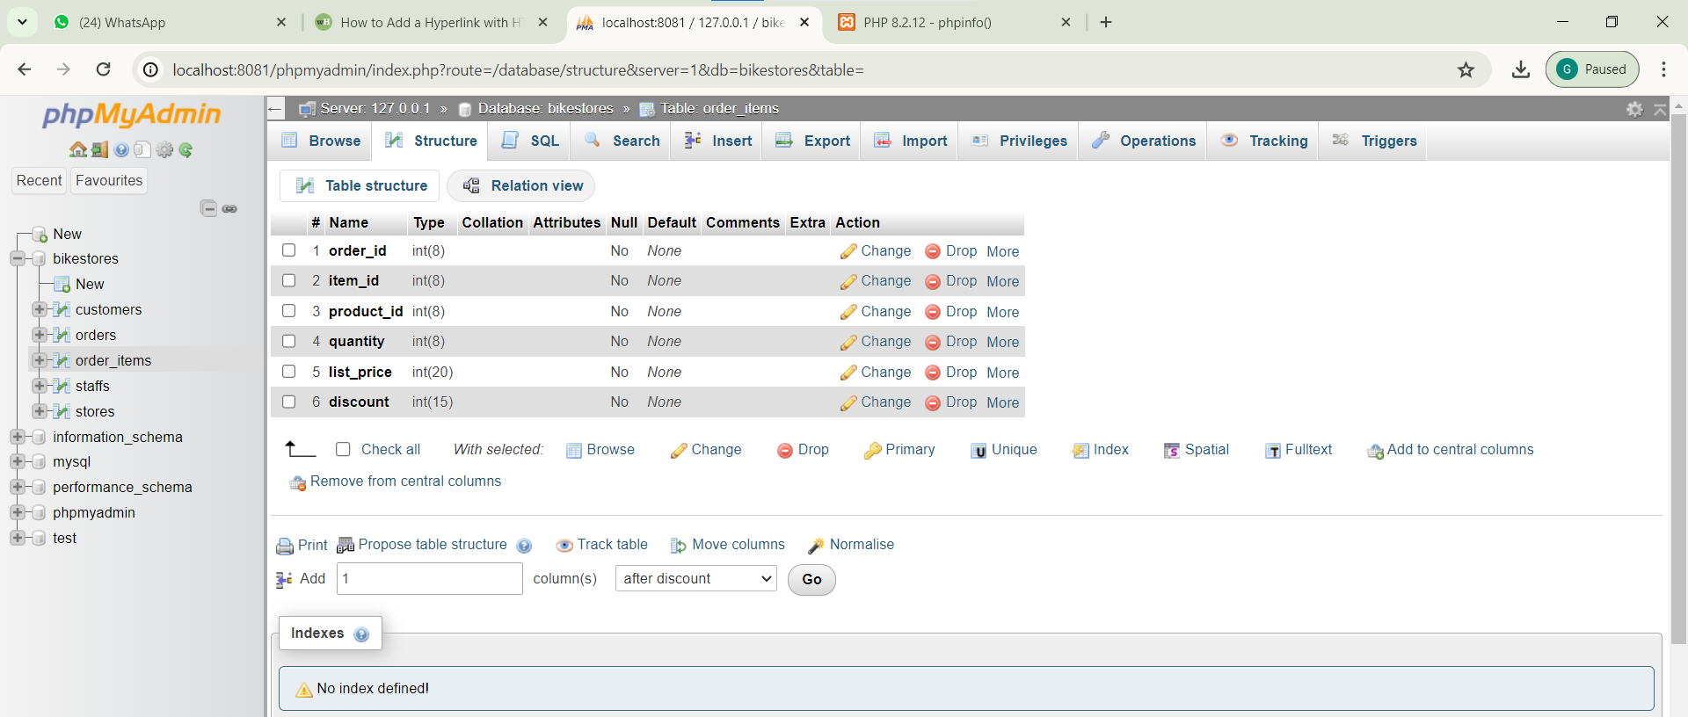

***Database # 06 “Categories”:***

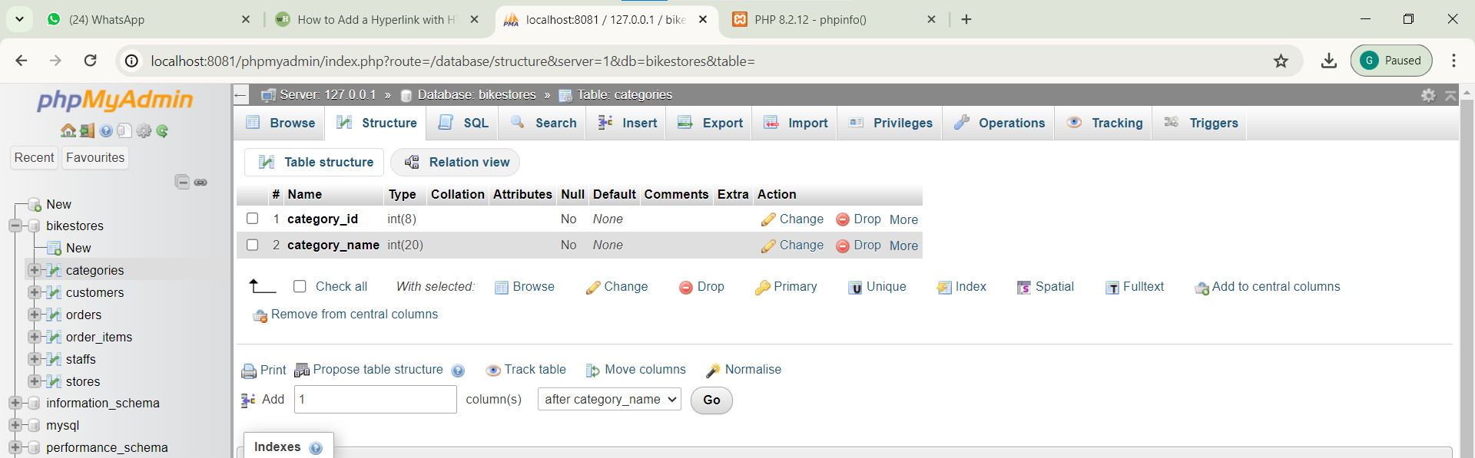

***Database # 07 “Products”:***

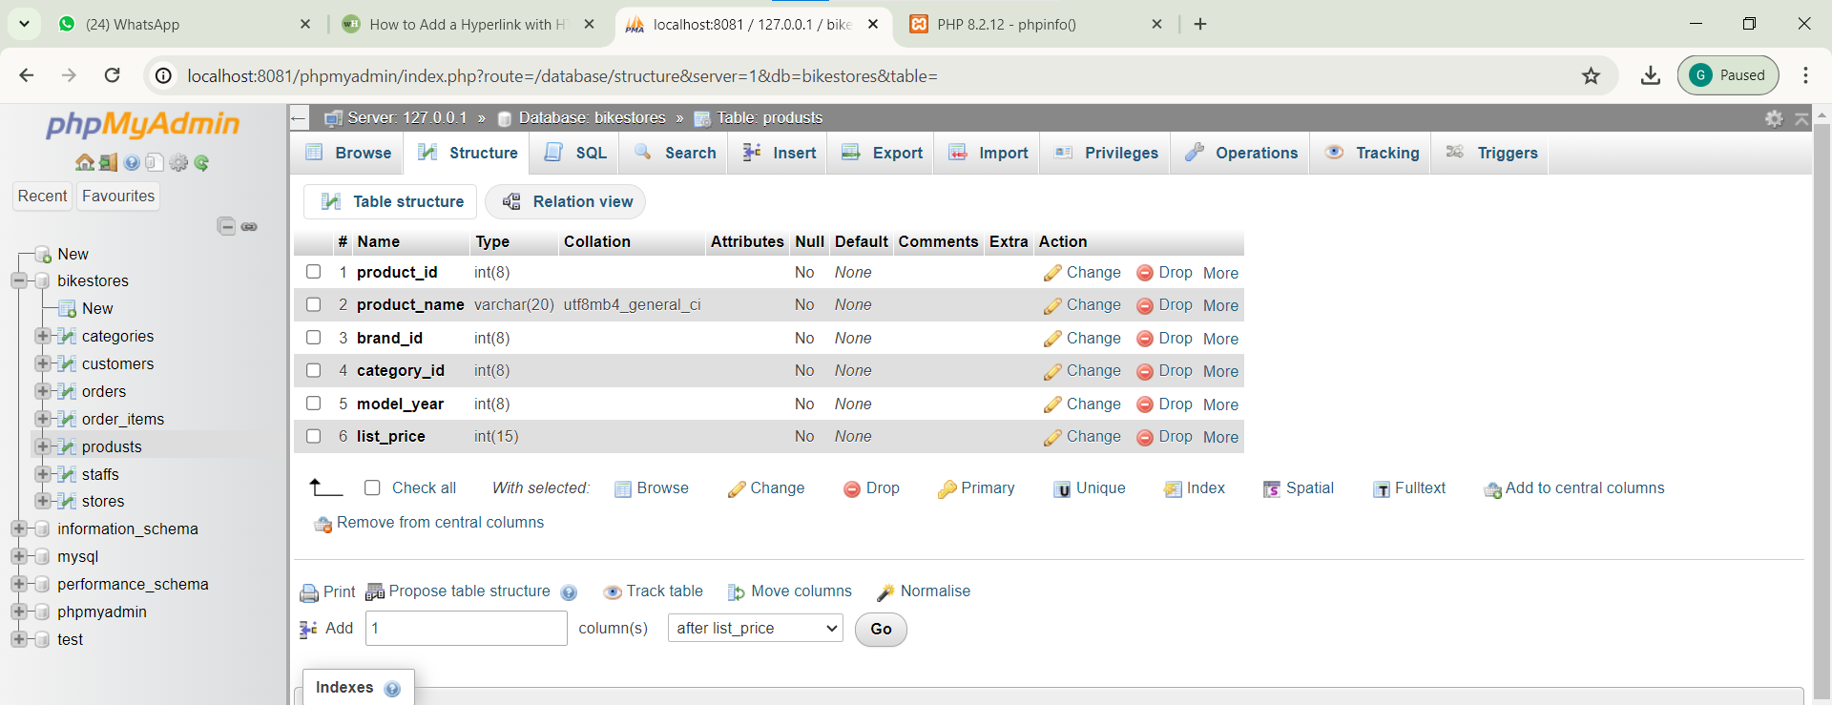

***Database # 08 “stocks”:***

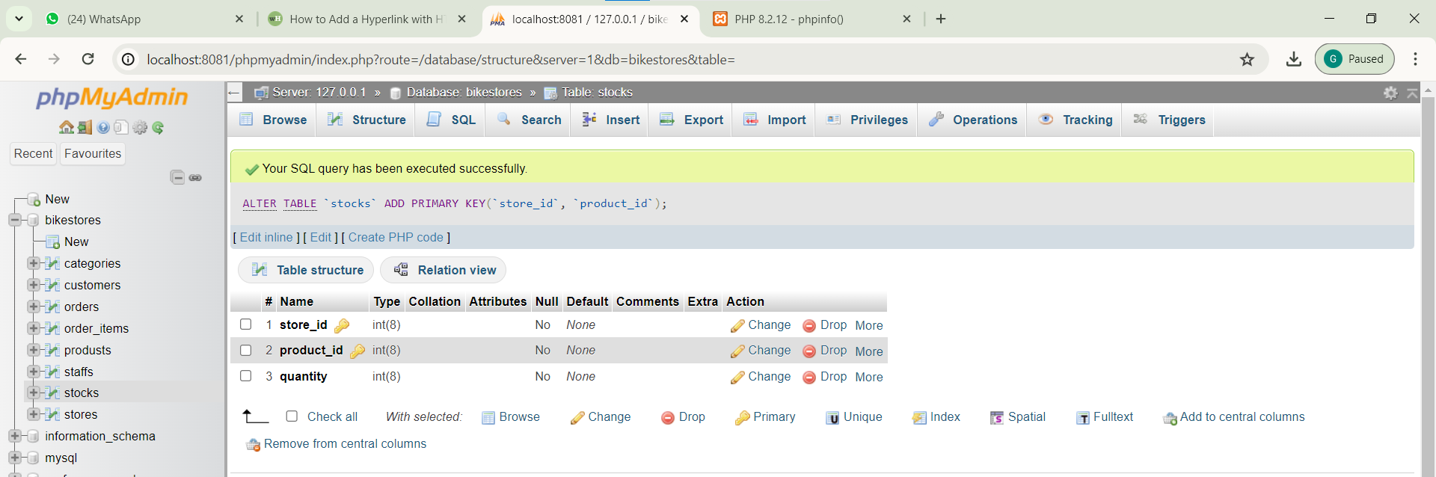

***Database # 09 “brands”:***

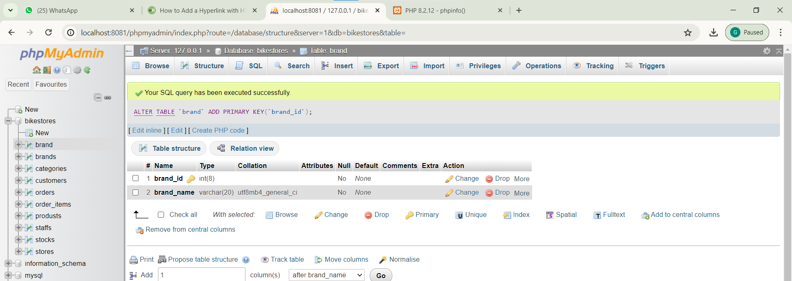

**LAB # *13***

***Show Authentication using PHP, Query, Database***

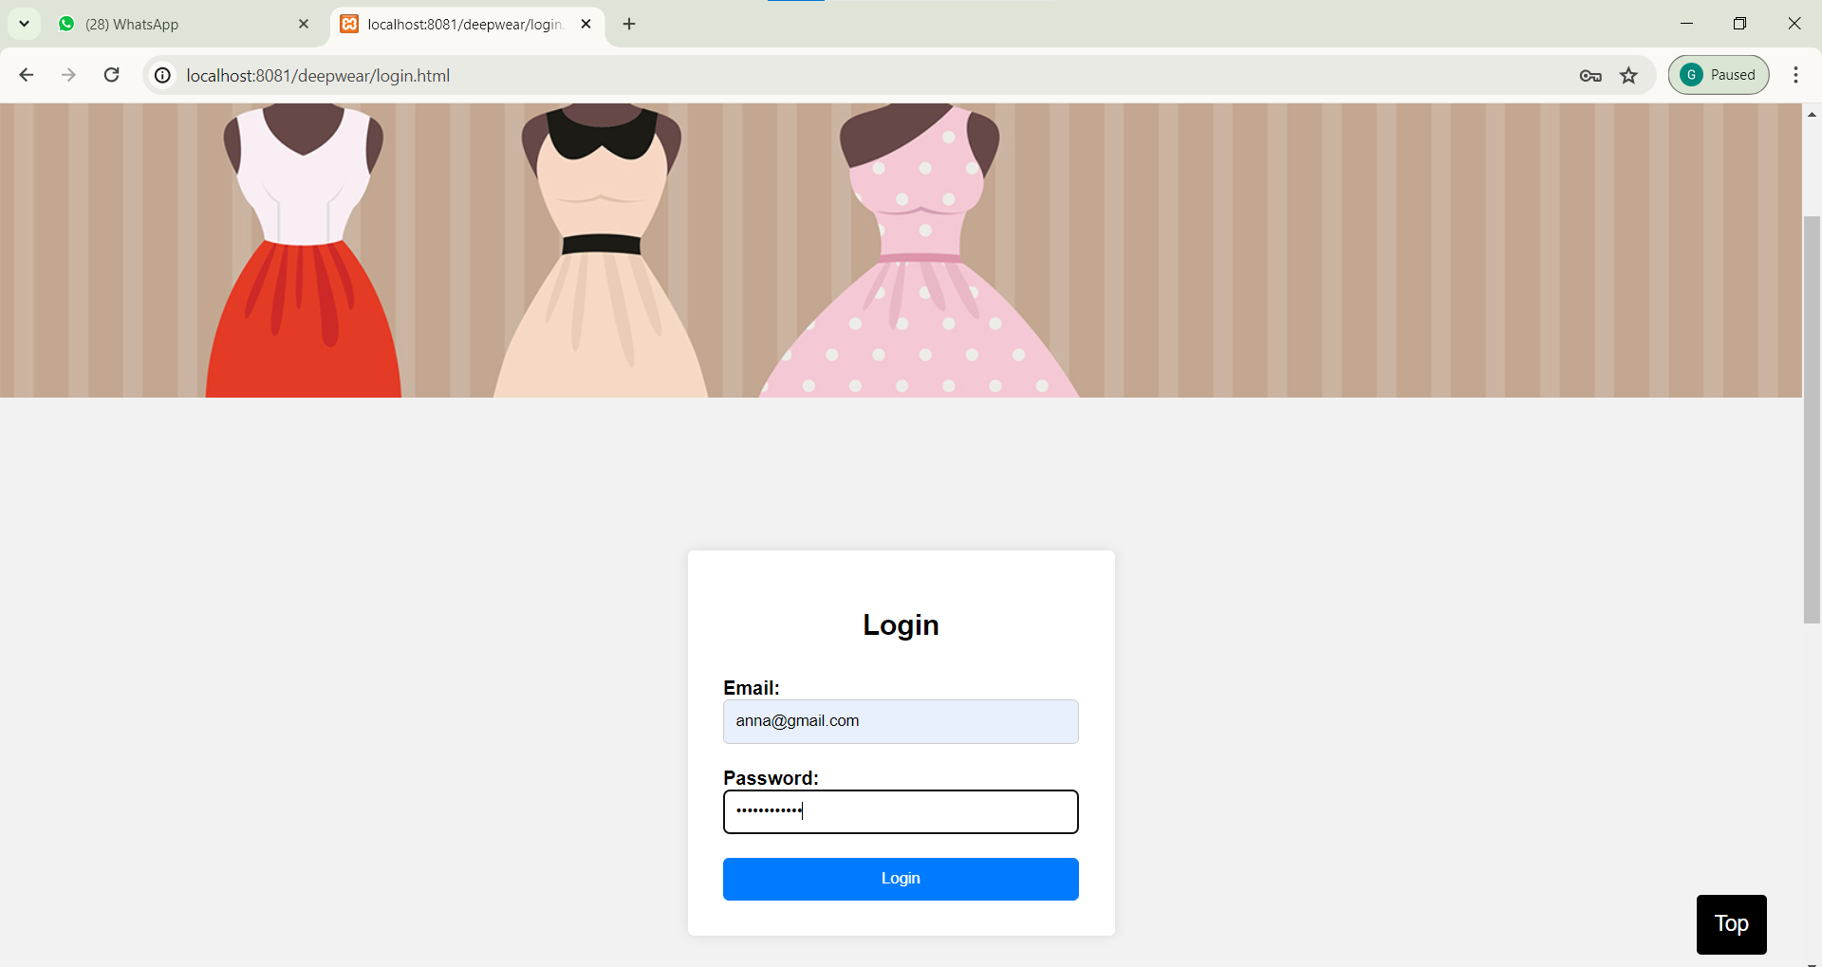

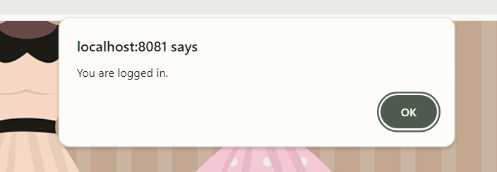

**LAB # *14***

***Use Dreamweaver Web Development Tool to view records***

